

Semester One Examination, 2021

Question/Answer booklet

MATHEMATICS  
METHODS  
UNIT 1

Section One:  
Calculator-free

Student’s name

Teacher’s name

|  |  |
| --- | --- |
| Number of additional answer booklets used (if applicable): |  |

## Time allowed for this section

Reading time before commencing work: five minutes

Working time: fifty minutes

## Materials required/recommended for this section

***To be provided by the supervisor***

This Question/Answer booklet

Formula sheet

***To be provided by the candidate***

Standard items: pens (blue/black preferred), pencils (including coloured), sharpener,  
correction fluid/tape, eraser, ruler, highlighters

Special items: nil

## Important note to candidates

No other items may be taken into the examination room. It is **your** responsibility to ensure that you do not have any unauthorised material. If you have any unauthorised material with you, hand it to the supervisor **before** reading any further.

## Structure of this paper

|  |  |  |  |  |  |
| --- | --- | --- | --- | --- | --- |
| Section | Number of questions available | Number of questions to be answered | Working time (minutes) | Marks available | Percentage of examination |
| Section One: Calculator-free | 8 | 8 | 50 | 52 | 35 |
| Section Two: Calculator-assumed | 15 | 15 | 100 | 98 | 65 |
|  | | |  | **Total** | 100 |

## Instructions to candidates

1. The rules for the conduct of examinations are detailed in the school handbook. Sitting this examination implies that you agree to abide by these rules.

2. Write your answers in this Question/Answer booklet preferably using a blue/black pen.  
Do not use erasable or gel pens.

3. You must be careful to confine your answers to the specific question asked and to follow any instructions that are specific to a particular question.

4. Show all your working clearly. Your working should be in sufficient detail to allow your answers to be checked readily and for marks to be awarded for reasoning. Incorrect answers given without supporting reasoning cannot be allocated any marks. For any question or part question worth more than two marks, valid working or justification is required to receive full marks. If you repeat any question, ensure that you cancel the answer you do not wish to have marked.

5. It is recommended that you do not use pencil, except in diagrams.

6. Supplementary pages for planning/continuing your answers to questions are provided at the end of this Question/Answer booklet. If you use these pages to continue an answer, indicate at the original answer where the answer is continued, i.e. give the page number.

7. The Formula sheet is not to be handed in with your Question/Answer booklet.

Section One: Calculator-free 35% (52 Marks)

This section has**eight** questions. Answer **all** questions. Write your answers in the spaces provided.

Working time: 50 minutes.

Question 1 (6 marks)

Solve the following equations for $x$.

(a) $\left(2x+5\right)\left(x-4\right)=0$. (2 marks)

(b) $x^{2}-10x-11=0$. (2 marks)

(c) ${\left(x-8\right)}^{2}-100=0$. (2 marks)

Question 2 (6 marks)

(a) The graph of $y=a\cos{(x+b)}$ is shown below, where $a$ and $b$ are positive constants.

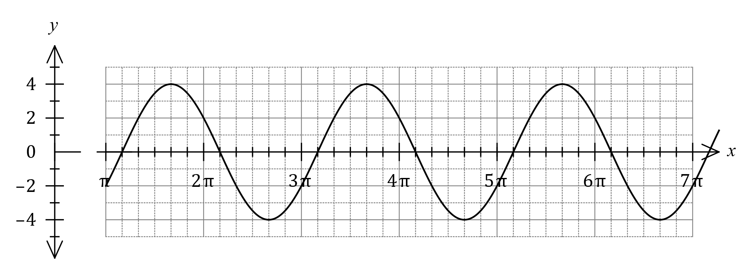

Determine the value of $a$ and the least value of $b$. (2 marks)

(b) Let $f\left(x\right)=3\tan\left(x+\begin{matrix}π \\ \overline{6}\end{matrix}\right)$.  
  
Determine the zeros of the graph of $y=f(x)$ for $0≤x≤2π$. (2 marks)

(c) Let $g\left(x\right)=\sin\left(\begin{matrix}x \\ \overline{3}\end{matrix}\right)-4$.

Determine the coordinates of the maximum of the graph of $y=g(x)$ for $0≤x≤2π$.

(2 marks)

Question 3 (7 marks)

Consider the function $f\left(x\right)=\begin{matrix}a \\ \overline{x+b}\end{matrix}$, where $a$ and $b$ are constants. The graph of $y=f(x)$ has an asymptote with equation $x=1$ and passes through the point $(3, -1)$.

(a) Determine the value of $a$ and the value of $b$. (3 marks)

(b) State the equation of the other asymptote of the graph of $y=f(x)$. (1 mark)

(c) Sketch the graph of $y=f(x)$ on the axes below. (3 marks)

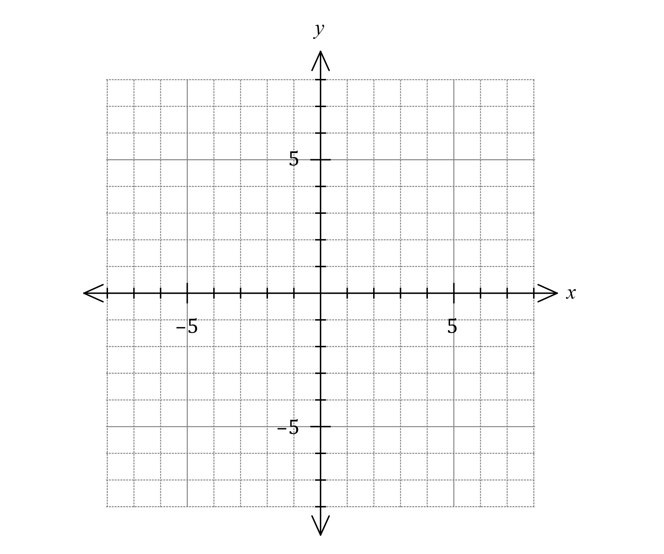

Question 4 (7 marks)

The straight line $L$ has equation $3x-2y=1$.

(a) Write the equation of $L$ in the form $y=mx+c$ to show that its gradient is $1.5$. (1 mark)

Line $L_{1}$ is parallel to $L$ and passes through the point $(2, -3)$.

Line $L_{2}$ is perpendicular to $L$ and passes through the point $(9, 1)$.

(b) Determine the point of intersection of $L_{1}$ and $L_{2}$. (6 marks)

Question 5 (7 marks)

(a) Determine the number of possible combinations when four students must be chosen from a small class of six. (2 marks)

(b) Determine the coefficient of the $x^{2}$ term in the expansion of

(i) ${\left(x+4\right)}^{3}$. (2 marks)

(ii) ${\left(5x-2\right)}^{6}$. (3 marks)

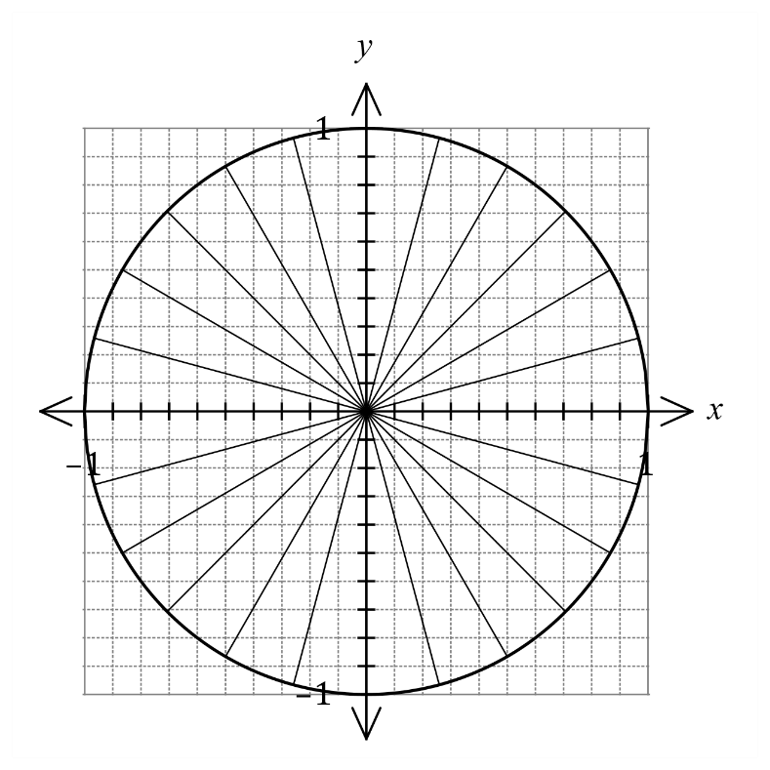Question 6 (6 marks)

1. A unit circle is shown.  
     
     
   Mark on the circumference of the  
   circle the points A and B so that  
   rays drawn from the origin to each point make anticlockwise angles

of $165°$ and $\begin{matrix}13π \\ \overline{ 12 }\end{matrix}$ from the positive

$x$-axis respectively.  
  
  
Hence estimate the value of $\cos{165°}$

and the value of $\sin\left(\begin{matrix}13π \\ \overline{ 12 }\end{matrix}\right)$.

(3 marks)

(b) Solve the equation $3\tan{(2x-10°)}=\sqrt{3}$ for $0°≤x≤180°$. (3 marks)

Question 7 (6 marks)

Two polynomial functions are defined by $f\left(x\right)=(4x-1)(x+2)$ and $g\left(x\right)=x^{3}+8x^{2}+6x-6$.

Determine the coordinates of the point(s) of intersection of $f(x)$ and $g(x)$.

Question 8 (7 marks)

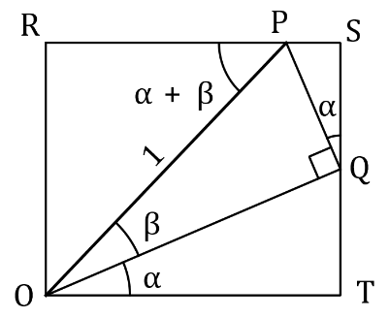Consider rectangle $ORST$ that  
contains the right triangle $OPQ$  
as shown.

Let the length of $OP=1,∠QOT=∠SQP=α,$ $∠POQ=β$ and $∠OPR=α+β$ 
.

(a) Show that $QT=\sin{α}\cos{β}$. (2 marks)

(b) Determine expressions for the lengths of $QS$ and $OR$ and hence prove the angle sum identity $\sin{(α+β)}=\sin{α}\cos{β}+\cos{α}\sin{β}$. (3 marks)

(c) Use the identity from part (b) to show that $\sin\left(x+\begin{matrix}3π \\ \overline{ 2 }\end{matrix}\right)=-\cos{x}$. (2 marks)

Supplementary page

Question number: _________

|  |  |  |  |
| --- | --- | --- | --- |
| Markers use only | | | |
| Marker | Question | Maximum | Mark |
| Mr Riemer | 1 | 6 |  |
| 2 | 6 |  |
| 3 | 7 |  |
| 4 | 7 |  |
| Ms Leow | 5 | 7 |  |
| 6 | 6 |  |
| 7 | 6 |  |
| 8 | 7 |  |
|  | Section 1 | 52 |  |
|  | Section 2 | 98 |  |
|  | Exam Total | 150 |  |
|  | Total | 100% |  |

© 2021 WA Exam Papers. Willetton Senior High School has a non-exclusive licence to copy and communicate this document for non-commercial, educational use within the school. No other copying, communication or use is permitted without the express written permission of WA Exam Papers. SN115-172-1.